**1. Introduction**

**1.1 Overview**

Carbon dioxide emissions are those stemming from the burning of fossil fuels and the manufacture of cement**.** They include carbon dioxide produced during consumption of solid, liquid and gas fuels and gas flaring. Human activities such as the burning of oil, coal and gas, as well as deforestation are the primary cause of the increased carbon dioxide concentration in the atmosphere.

**1.2 Purpose**

The carbon in co2 can be used to produce fuels that are in use today, including methane, methanol, gasoline and aviation fuels. The process involves using the co2 in combination with hydrogen,which is highly energy intensive to produce, and results in a carbon-containing fuel that is easier to handle and use than pure hydrogen.

**2. Problem Definition & Design Thinking**

**2.1 Empathy Map**

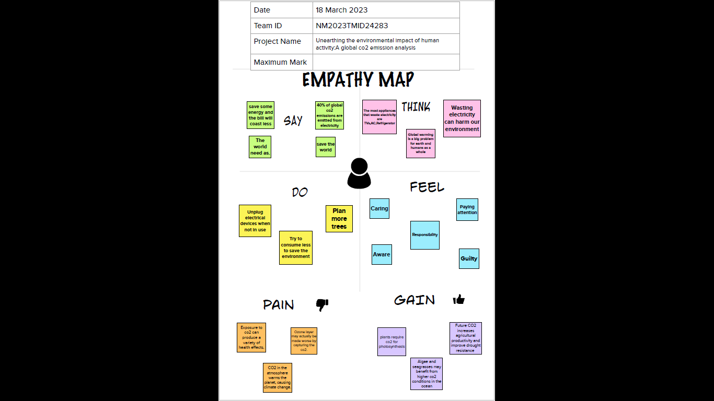

**2.2 Ideation & Brainstorming Map**

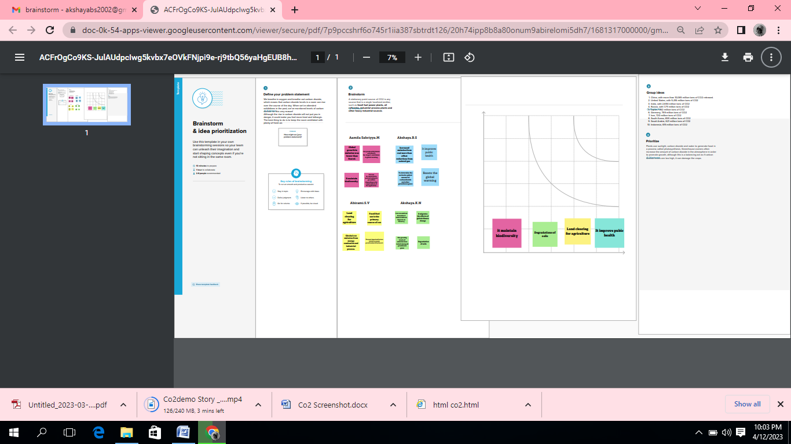

**3. Result**

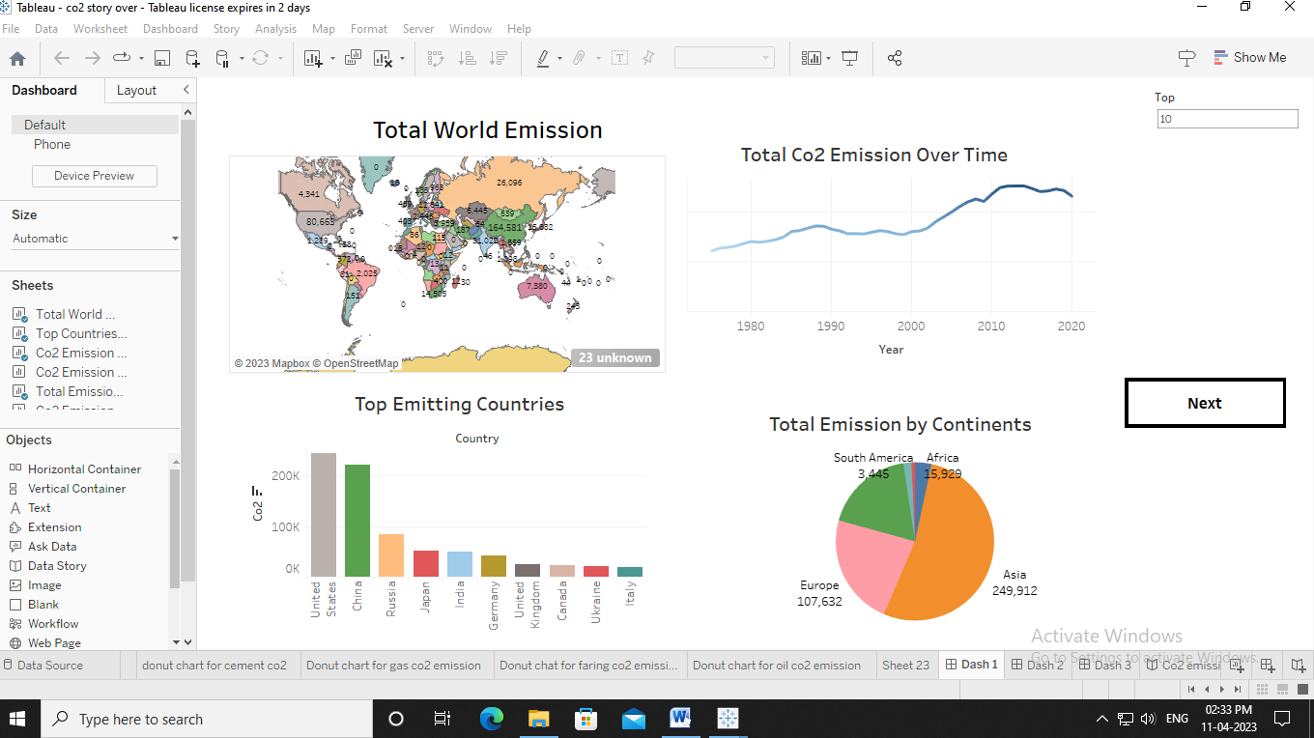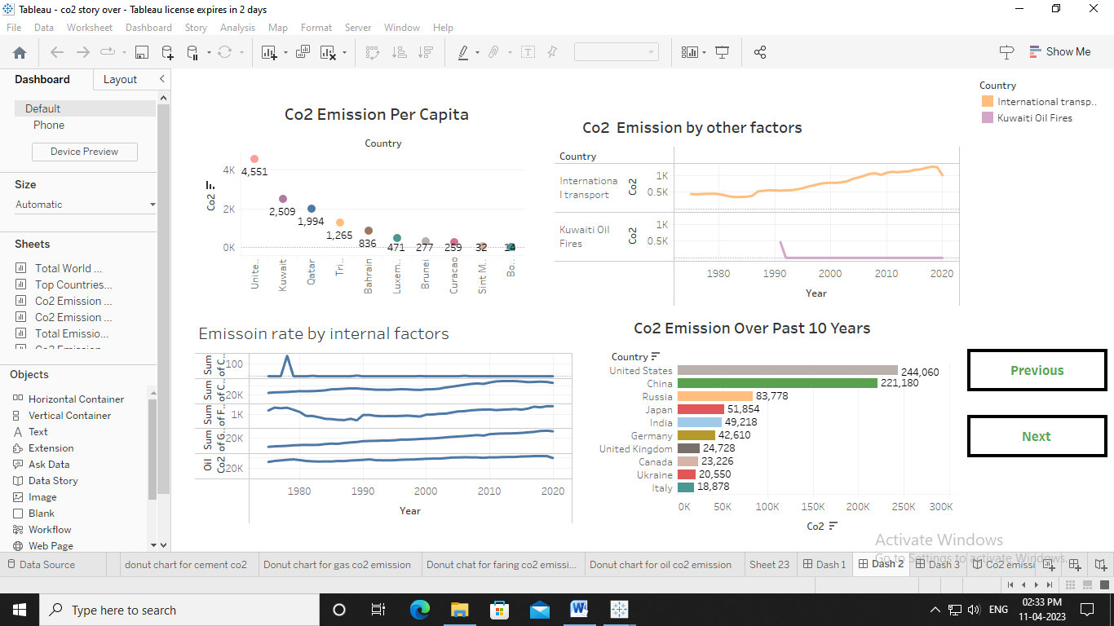

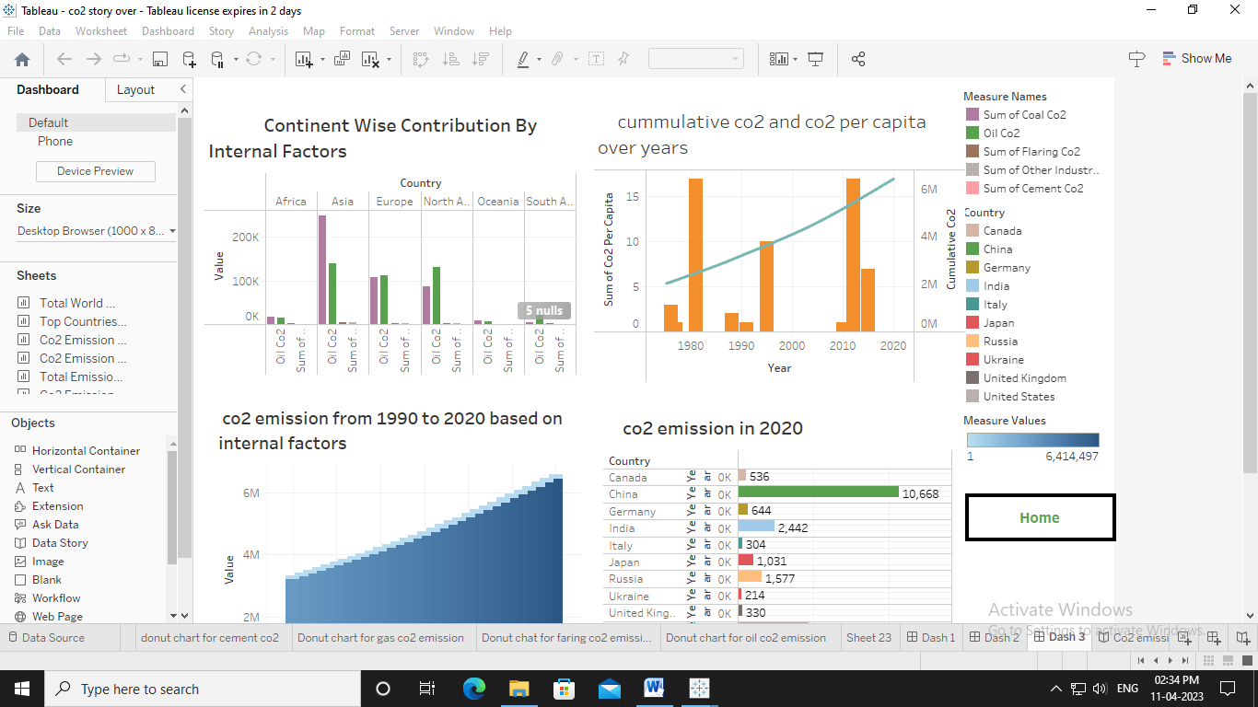

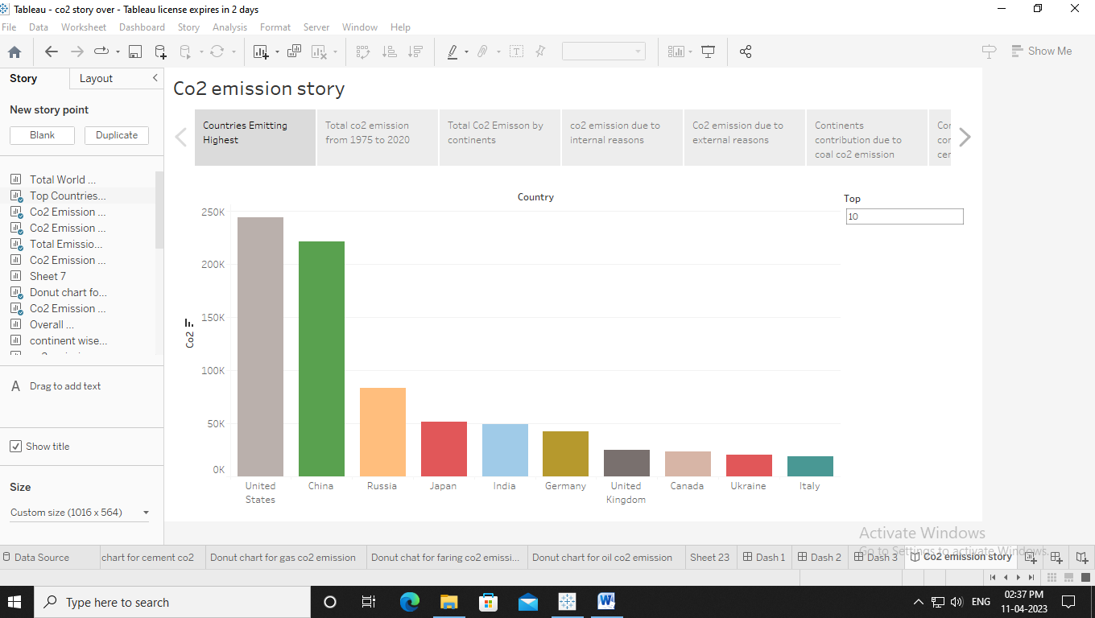

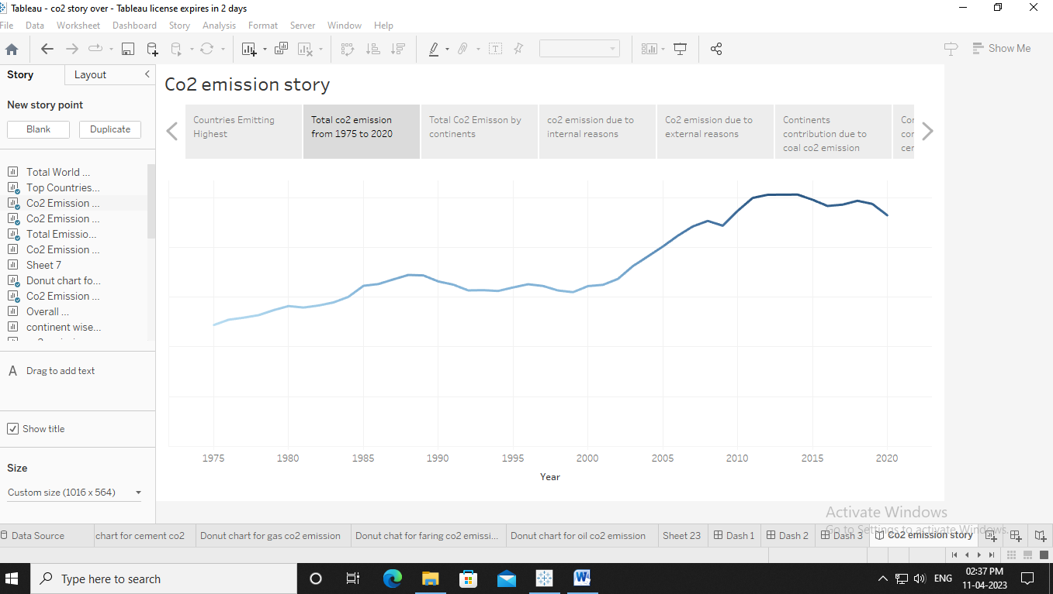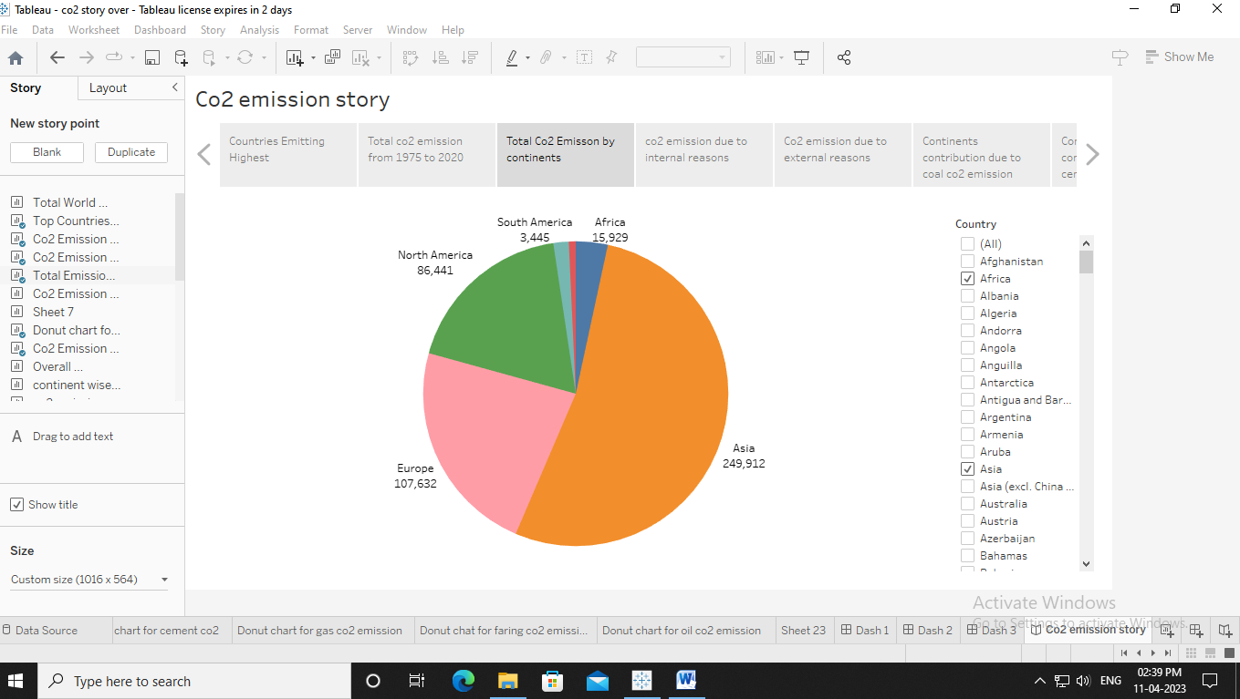

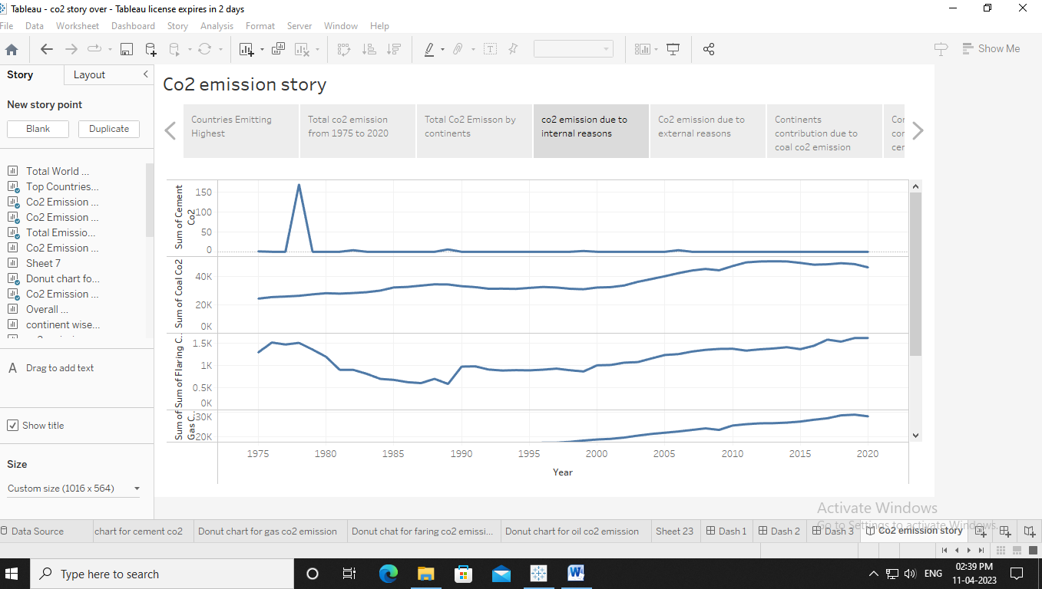

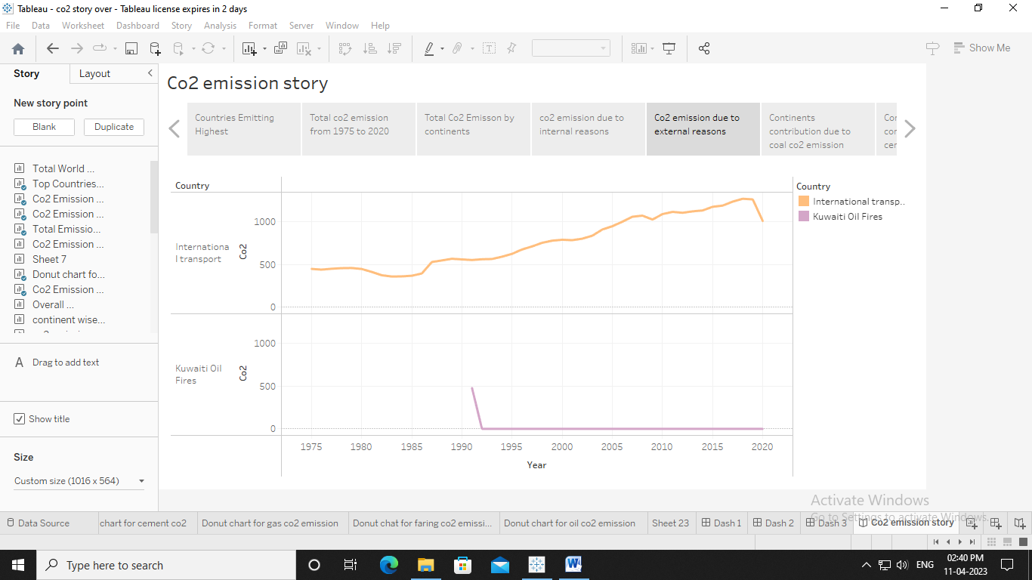

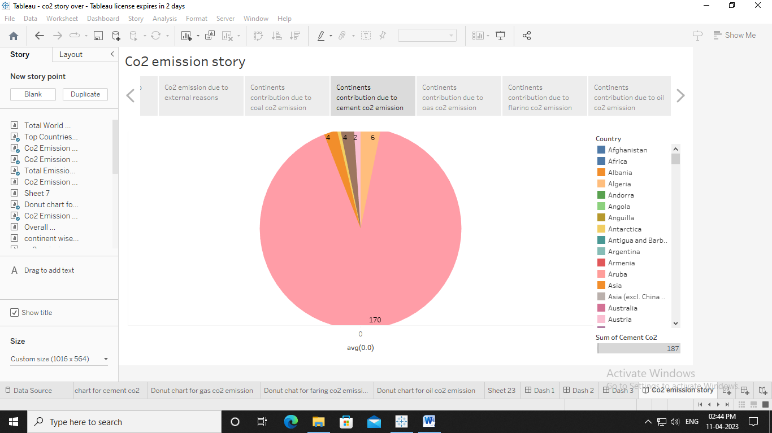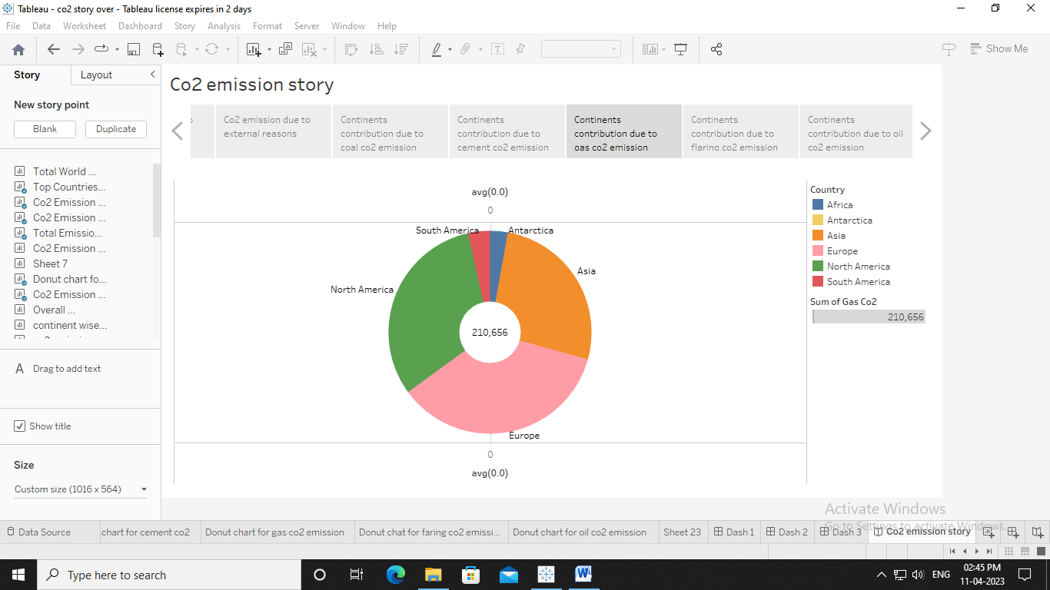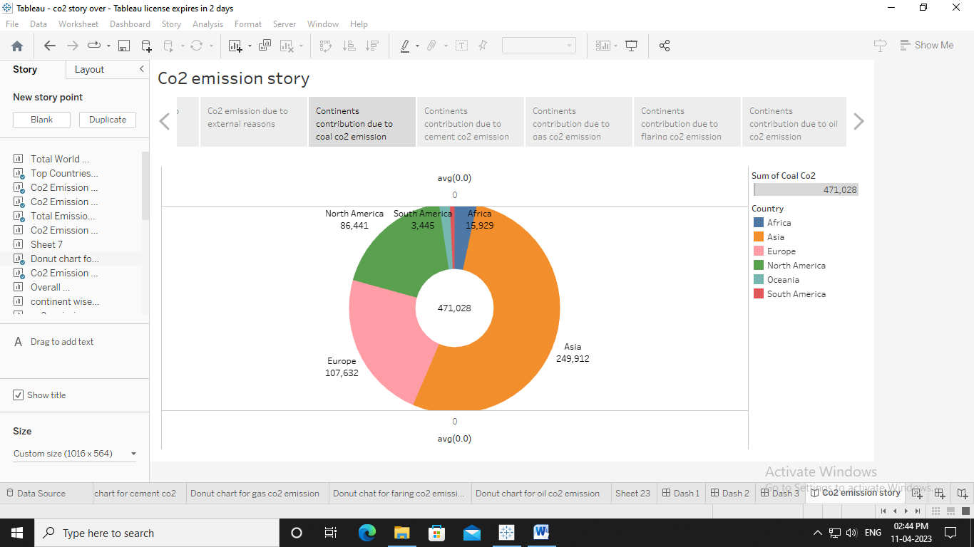

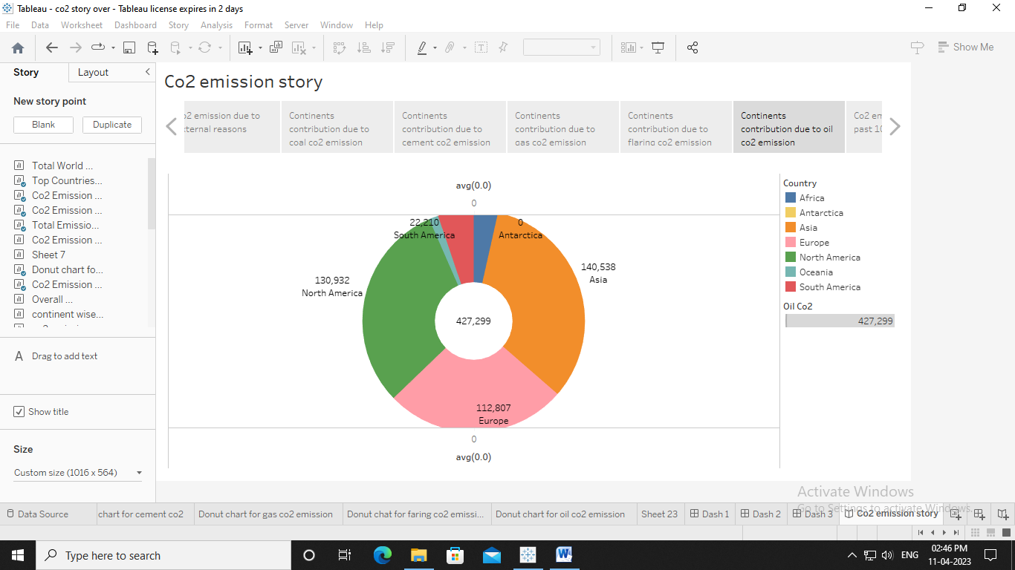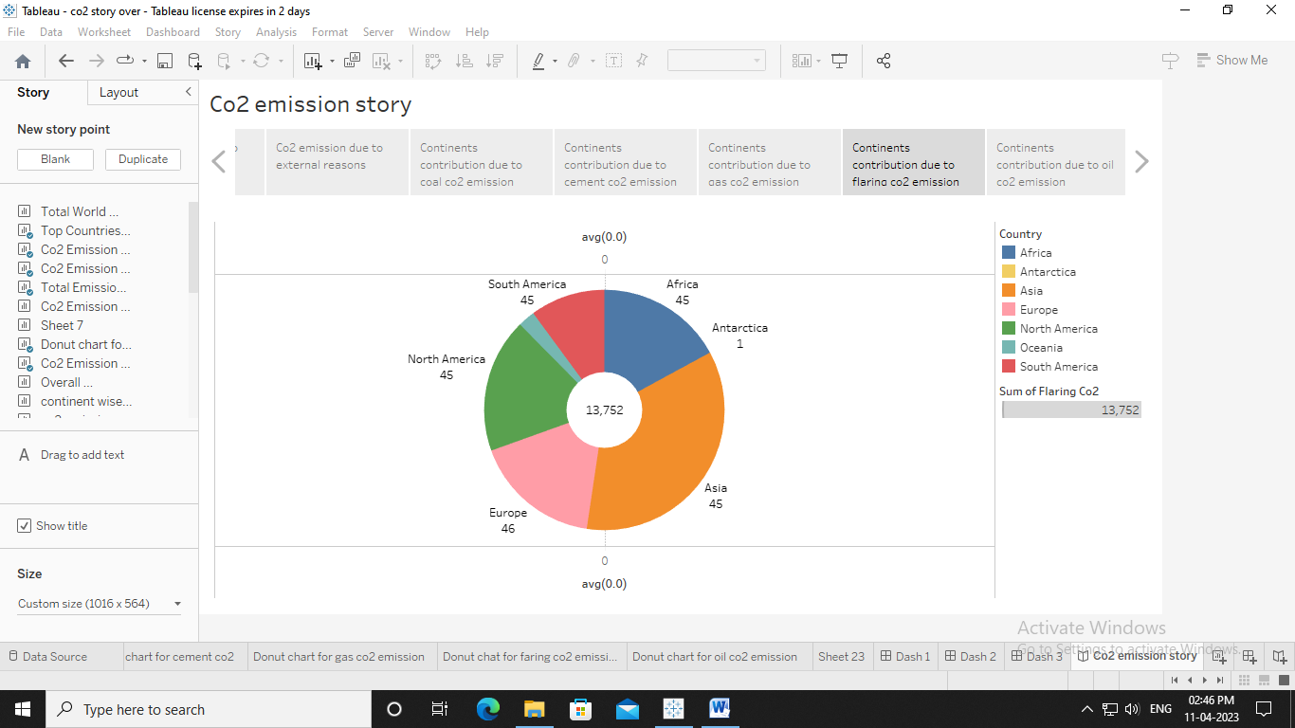

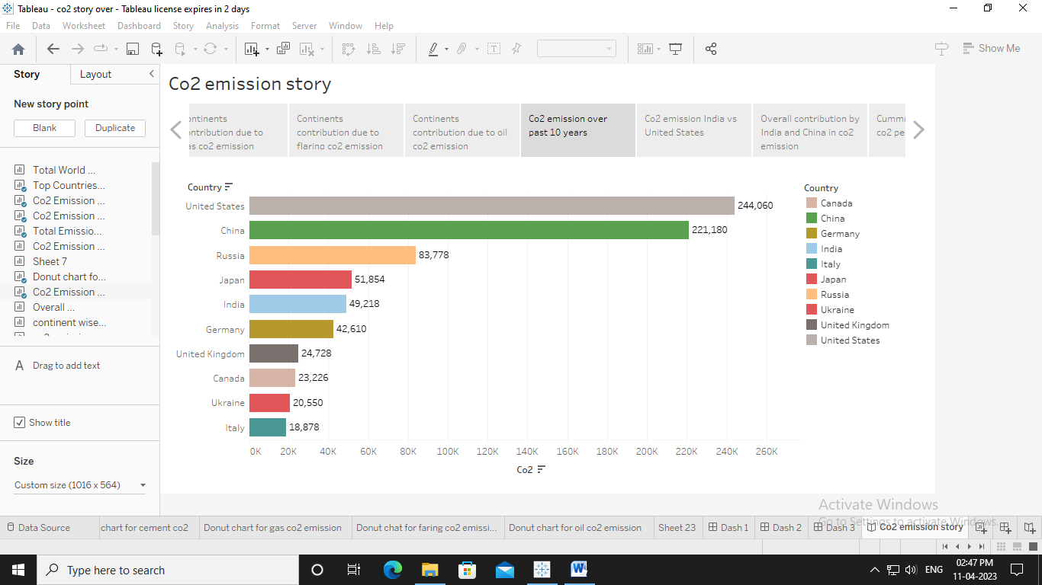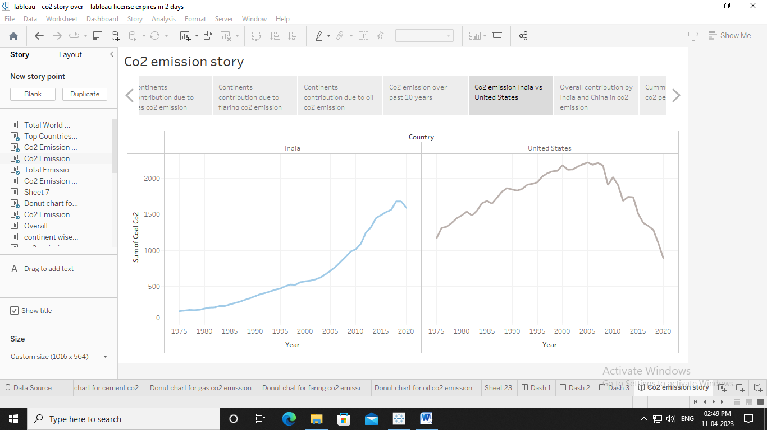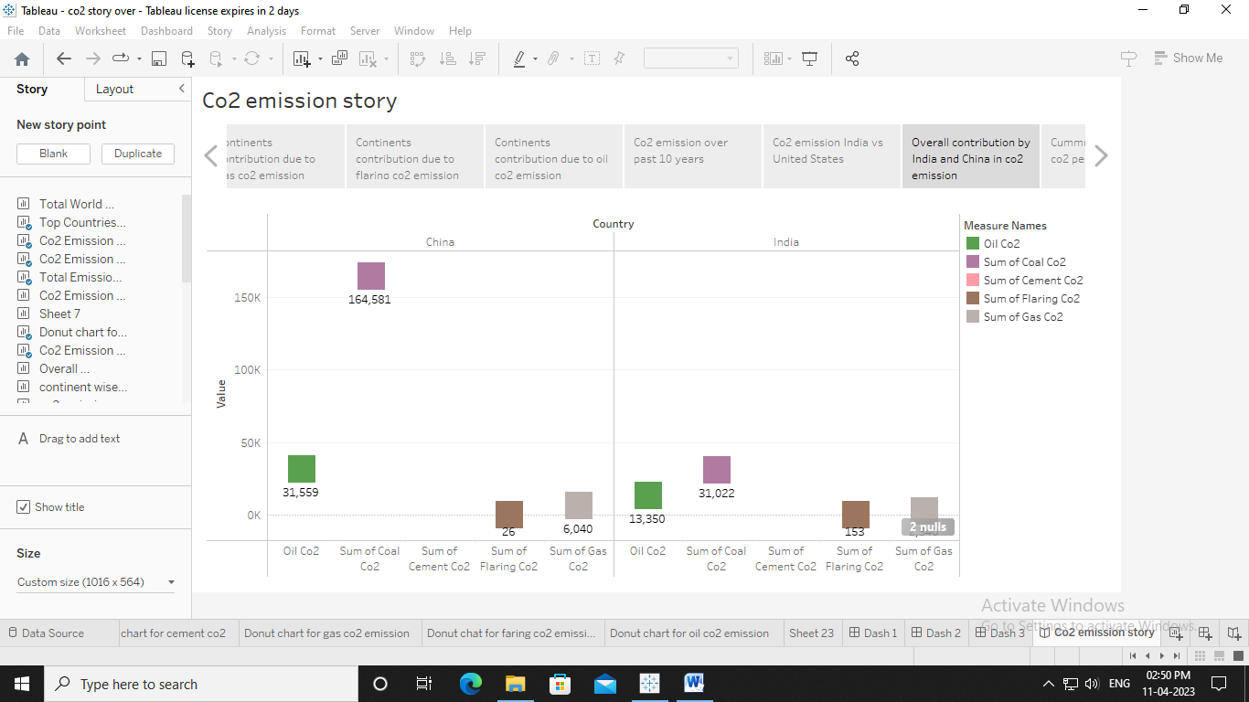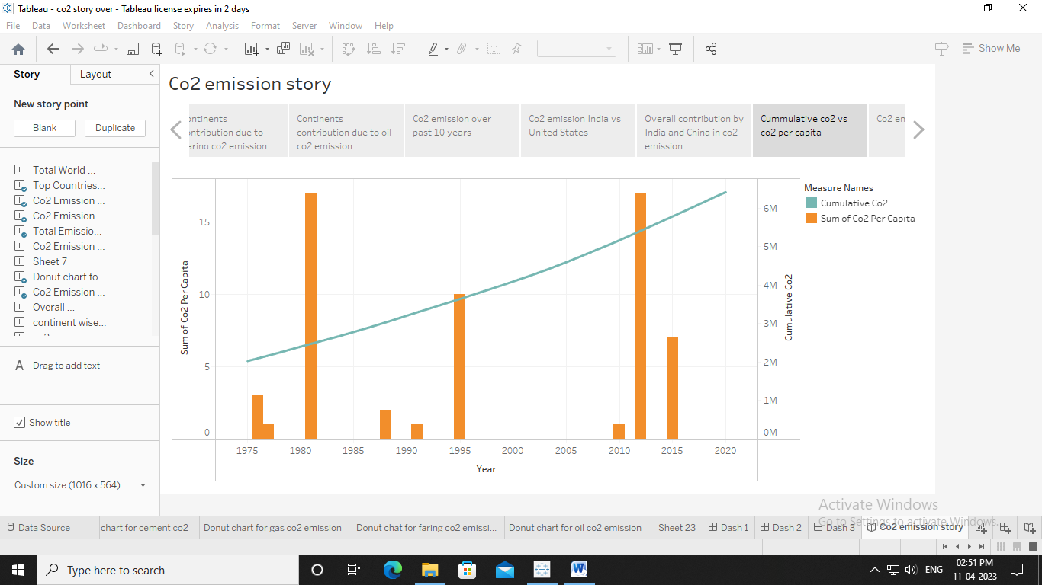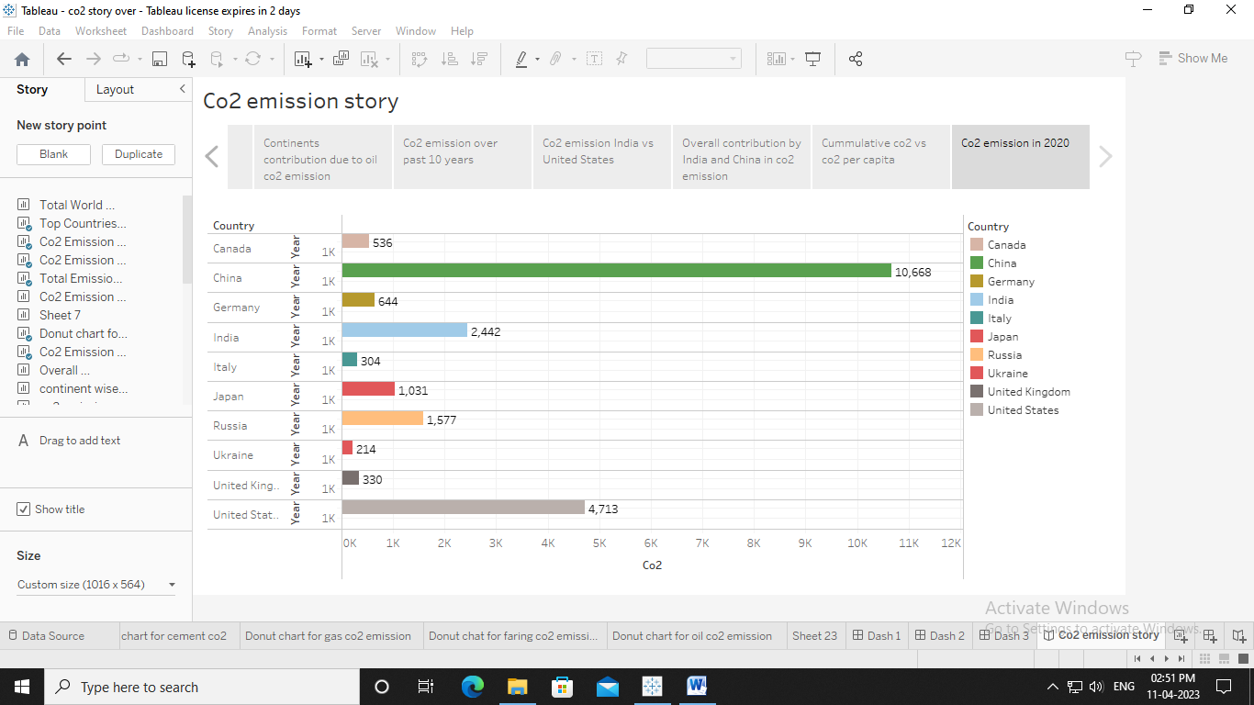

**4. Advantages and Disadvantages**

**Advantages :** Most of the carbon dioxide that people put into the atmosphere comes from burning fossil fuels such as oil,coal, and natural gas.Carbon dioxide is an important greenhouse gas that helps to trap heat in our atmosphere.

**Disadvantages :** As co2 levels rise, the Earth’s temperature rise with it, causing the melting of the polar ice caps directly into the oceans. Increased water levels lower our oceanfront wetlands and sea fronts.

**5. Applications**

The production of CO2-based fuels and chemicals is energy-intensive and requires large amounts of hydrogen. The carbon in CO2 enables the conversion of hydrogen into a fuel that is easier to handle and use, for example as an aviation fuel. CO2 can also replace fossil fuels as a raw material in chemicals and polymers.

**6.Conclusion**

"The rising level of atmospheric CO2 could be the one global natural resource that is progressively increasing food production and total biological output, in a world of otherwise diminishing natural resources of land, water, energy, minerals, and fertilizer.

**7.Future Scope**

In the Annual Energy Outlook 2022 (AEO2022) Reference case, which assumes no changes to current laws or regulations, the U.S. Energy Information Administration (EIA) projects that U.S. energy-related carbon dioxide (CO2) emissions will fall to 4.5 billion metrictons in 2037, or 6% below the energy-related CO2 .

**8. Appendix**

**file:///C:/Users/user4/Downloads/html%20co2%20(3).html**